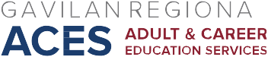

AB 104 Consortium Meeting
November 3, 2017
Agenda

- Approve October 6, 2017 minutes

- Updates/Announcements:

- Newsela: contact Jacob Zachs if interested @ :jacob.zachs@newsela.com
- Educate and Elevate campaign @ educateandelevate.org/california
- New fiscal system: October 25 launch/December 15 16/17-17/18 budgets due; archived webinar available @ aebg.cccco.edu
- October 27, 2017 contribution - $973.74/18 ACES participants; 1 presenter
- PD Opportunity January 22, 2018
- TAP – PD
- MHUSD
- GUSD
- Noncredit
- SBHSD

- 2018-2021 Three Year Plan: Discuss vision

Next Meeting: November 17, 2017, 2:30-4:30, ESL Computer Lab Conference Room

